*Florida International University*

*School of Computing and Information Sciences*

CIS 4911 - Senior Capstone Project

Software Engineering Focus

Feature Document

User Story #627

**Team Member:**

Andrew Mitchell

**Product Owner(s)**:

Francisco R. Ortega

**Mentor(s)**:

Francisco R. Ortega

...

**Instructor**: Masoud Sadjadi

**User Story - Create Layer Visualization Menu**

* As a User I want an interface to view which layers are currently active and on top of eachother.

Acceptance Criteria

* Show which layers are currently on top of one another.
* Show which layers are being drawn.

**Use Case**

Use Case

Enable the user to see all the available drawing layers. As well as select which one belongs on top.

Details:

Actor: User

Pre-conditions:

Multitouch must be working.

Description:

Use case begins when the user taps the layers button (Looks like two sheets of paper). When they tap the icon three more boxes should pop up (or however many layers are currently available). These boxes show what is currently drawn on each layer (May be stretched, but gives an idea).

Post-conditions:

All drawings after changing layers should be drawn on that specific layer.

Decision Support:

Frequency: Often. Layering is a very popular concept for drawing programs. Anyone that has used a decent drawing program understands how to use layering to add to their drawings.

Criticality: High. It is a very part of the project for the product owner. He believes layering is of high importance to drawing applications.

Risk: Medium. Restructure how our FrameBuffer Objects work. Have to learn to capture our framebuffers to small locations.

Reliability: Highly.

Mean time to Failure –  Almost never. It should only ‘fail’ when the user misses the button.

Availability – Available when ‘mode buttons’ are enabled.

Performance:

N/a

Supportability:

Must work with ACER Multitouch.

Leap motion device

Modification History:

Owner: Andrew Mitchell

Initiation date: 03/8/2016

Date last modified: 03/8/2016

**Use Case Diagram**

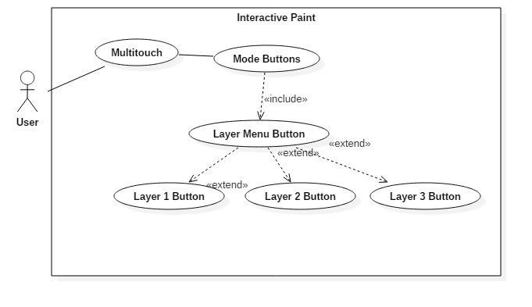

**Sequence Diagram**

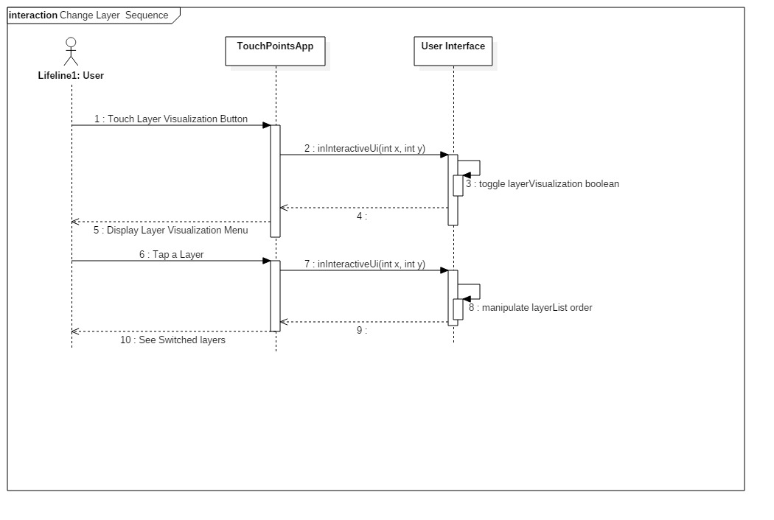

**Class Diagram**

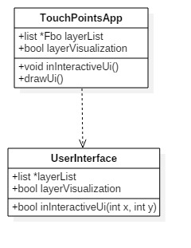

**Unit Test**

Sunny Day :

User selects first layer

Nothing happens.

User Selects second layer

First layer is ‘swapped’ with second layer

User draws

Draws successfully on new ‘first layer’

User selects third layer

First layer is ‘swapped’ with third layer.

User Draws

Draws successfully on new ‘first layer’

User Draws

Drawing is successfully reflected inside the layer buttons.

Rainy Day Tests :

* User clears the screen
  + Layers are still visible behind one another. Did not just fill the background with black.

**Integration Test**

Currently works will Touchshapes, leapmotion, and multitouch implementations.

**User Guide**

Press the layer button (‘two sheets of paper’) to pull up the layers menu.

Then select one of the three layers which are outlined.

The layers should have a drawing reflecting which layers are which.

The top icon is the layer currently on top (where you are drawing), while the second layer is below, and the bottom icon is the layer on the bottom.

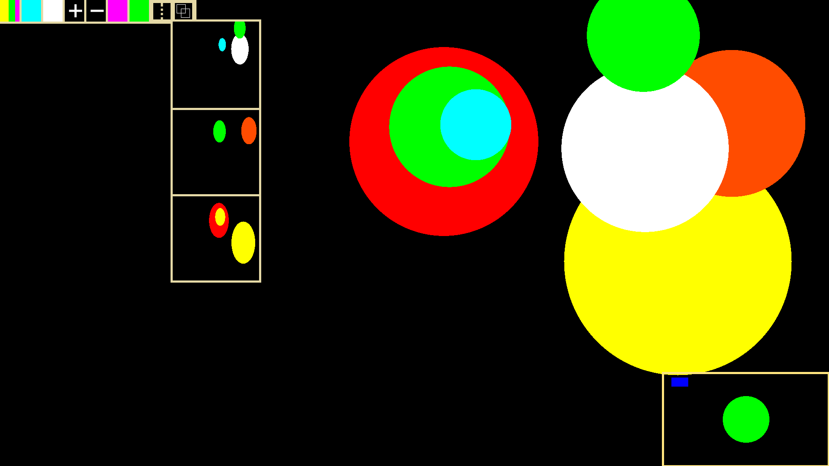

We can see the layer buttons here, showing which layer has what information stored on it. The layer on top is the current ‘top layer’ and is drawn above everything else. The layer on the bottom is also drawn on the ‘bottom’.

Press either the second or third layer icon to ‘swap’ the layer with your current first layer.

**Glossary**

Layers – A layer is a frame buffer object which can be drawn on top or below another layer. Creating more dynamic pictures.